# UFC world champion Logo [ Download - Logo - icon ] png svg

UFC Relational Database

Matthew Laken

December 2020

IST 659 M403

**Contents:**

1

**Part One:** 2

Summary: 2

Stakeholders: 3

Business Rules: 3

Glossary: 4

Data Questions: 4

Conceptual Model: 5

Logical Model: 6

**Part Two:** 7

Physical Database Design: 7

Building Tables: 7

Data Creation: 10

Views & Functions: 27

Data Manipulation: 30

Answering Data Questions: 31

Implementation: 36

Reflection: 36

Summary: 37

# **Part One:**

## Summary:

The purpose of my database is to create a predictive model to be applied for sports with an individual competitor, for this assignment, I am focusing on the UFC. I have generated a relational database that contains the UFC roster as well as all fight cards tracing back a certain period of time. My intentions are for one to be able to utilize this database to make informed decisions on the result of an upcoming match based on a fighter’s history and the history of the UFC. The fighter data is broken down by weight class and fights will be tracked by card. To determine the amount of time covered, I will include all cards tracing back over 10 years, as most careers do not last 10 years in this sport. Understanding that the fighters have a professional record of their total competitions, for purposes of my assignment I am limiting my league to the UFC. Quick disclaimers here: the fighters record will only summarize fights in the database, not including any fight prior to the database record or in a league other than the UFC. This database will contain information about the match including but not limited to statistics of each fighter and result of the contest. I plan to allow for my database to contain multiple leagues and expand on the amount of data recorded for each match in future iterations.

## Stakeholders:

The stakeholders here are sports gamblers and fanatics. I will serve as the majority stakeholder as I am both a fan of the UFC, as well as a gambler. I believe by analyzing previous match statistics I will be able to generate an accurate prediction for the tale of the tape between two fighters who are set to meet in the octagon, thus making a more informed decision on who is going to win that fight, how are they going to win it and how long will the match last. Ideally, with the expansion of the there is a need for analytical tools to help gamblers make more informed bets. For purposes of this assignment and that this is a database course, I am focusing more on the relational database rather than the statistics that go into a predictive model.

## Business Rules:

* Each League has **one or more** Fight Cards
* Only **one** League is a part of **one** Fight Card.
* Each League has **many** Fighter(s).
* A Fighter can be in **one or many** League(s).
* Each Fighter has **one or more** Stance(s)
* A Fighter fights on **one or more** Fight Card(s).
* A Fight Card has **one or more** Match(es).
* A Match is fought on **only one** Fight Card.
* Each Match is determined by/ has **one** Winner.
* Each Match is determined by/ has **one** Loser.
* Each Fighter has **one** Match on **one** Fight Card.
* Each Match has **only one** Weight Class.
* A Fighter fights in **one or more** Weight Class(es).
* Each Match has **one** (finishing) Method.
* Each Match has **one** (finishing) Move.
* A (finishing) Method has **one or more** (finishing) Move(s).

## Glossary:

|  |  |
| --- | --- |
| **Attribute** | **Definition** |
| Att | Attempted [in a fight] |
| FightCard | Scheduled group of matches highlighted by a main event |
| FinishRound | Round Fight Ends In |
| FinMove | Finished Maneuver used to end a fight |
| Height | Height of the fighter recorded at the weigh in before the fight |
| KD | Knockdown [recorded in a fight] |
| Land | Landed [in a fight] |
| Method | Method of Victory [way fight ends] |
| Octagon | Place where a UFC match takes place |
| Odds | Betting Odds Fighter Wins (Money Line -100/100) |
| Reach | Reach of the fighter recorded at the weigh in before the fight |
| SigStr | Significant Strike [recorded in a fight] |
| Stance | Footing of fighter when in a match |
| SubAtt | Submission Attempted [recorded in a fight] |
| Td | Takedown [recorded in a fight] |
| TitleBout | Is this fight for a title? (True/False) |
| TotalRound | Total number of rounds in a fight [3,5] |
| TotalTime | Total Duration of Fight in seconds. |
| TotStr | Total Strike [recorded in a fight] |
| UFC | Mixed Martial Arts League: Ultimate Fighting Championship |
| Venue | Location of fight card |
| Weight | Weight of the fighter recorded at the weigh in before the fight |
| WeightClass | Division of fighters broken down by weight and gender |

## Data Questions:

1. How many fights are finished compared to the number decided by the judges score card?
2. What is the most utilized finishing move(s) and how quickly are they executed?
3. What are the differences in strikes landed/thrown for different weight classes?
4. What is the average duration of a match and how this differs for weight class?
5. How many attempts does it take to land a submission?

## Conceptual Model:

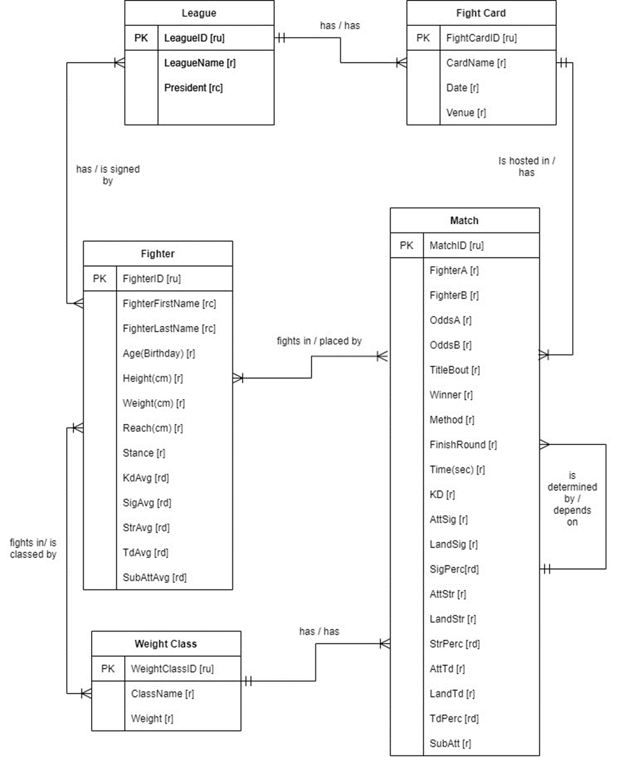

## Logical Model:

# **Part Two:**

## Physical Database Design:

### Building Tables:

/*

Dont want to lose all my imports ***

DROP TABLE IF EXISTS TheMatch

DROP TABLE IF EXISTS FightCard

DROP TABLE IF EXISTS WeightClass

DROP TABLE IF EXISTS Loser

DROP TABLE IF EXISTS Winner

DROP TABLE IF EXISTS MethMove

DROP TABLE IF EXISTS Method

DROP TABLE IF EXISTS FinMove

DROP TABLE IF EXISTS LeagueFighter

DROP TABLE IF EXISTS Fighter

DROP TABLE IF EXISTS Stance

DROP TABLE IF EXISTS League

*/

-- creating league table

CREATE TABLE League (

-- col for table

LeagueID int identity,

LeagueName varchar(20) not null,

President varchar(200),

-- constraints

CONSTRAINT PK_League PRIMARY KEY (LeagueID)

)

-- end of table

-- creating Stance table

CREATE TABLE Stance (

-- col for table

StanceID int identity,

Stance varchar(20) not null,

-- constraints

CONSTRAINT PK_Stance PRIMARY KEY (StanceID)

)

-- end of table

-- creating Fighter table

CREATE TABLE Fighter (

-- col for table

FighterID int identity,

FighterName varchar(20) not null,

StanceID int,

-- constraints

CONSTRAINT PK_Fighter PRIMARY KEY (FighterID),

CONSTRAINT FK1_Fighter FOREIGN KEY (StanceID) REFERENCES Stance(StanceID)

)

-- end of table

-- creating LeagueFighter table

CREATE TABLE LeagueFighter (

-- col for table

LeagueFighterID int identity,

LeagueID int,

FighterID int,

-- constraints

CONSTRAINT PK_LeagueFighter PRIMARY KEY (LeagueFighterID),

CONSTRAINT FK1_LeagueFighter FOREIGN KEY (LeagueID) REFERENCES League(LeagueID),

CONSTRAINT FK2_LeagueFighter FOREIGN KEY (FighterID) REFERENCES Fighter(FighterID)

)

-- end of table

-- creating FinMove table

CREATE TABLE FinMove (

-- col for table

FinMoveID int identity,

FinMoveName varchar(20) not null,

-- constraints

CONSTRAINT PK_FinMove PRIMARY KEY (FinMoveID)

)

-- end of table

-- creating Method table

CREATE TABLE Method (

-- col for table

MethodID int identity,

MethodName varchar(20) not null,

-- constraints

CONSTRAINT PK_Method PRIMARY KEY (MethodID)

)

-- end of table

-- creating MethMove table

CREATE TABLE MethMove (

-- col for table

MethMoveID int identity,

MethodID int,

FinMoveID int,

-- constraints

CONSTRAINT PK_MethMove PRIMARY KEY (MethMoveID),

CONSTRAINT FK1_MethMove FOREIGN KEY (MethodID) REFERENCES Method(MethodID),

CONSTRAINT FK2_MethMove FOREIGN KEY (FinMoveID) REFERENCES FinMove(FinMoveID)

)

-- end of table

-- creating Winner table

CREATE TABLE Winner (

-- col for table

WinnerID int identity,

FighterID int,

FinishRound int,

TotalTime int,

WinOdds int,

WinHeight int,

WinWeight int,

WinReach int,

WinAge int,

WinKD int,

WinSigStrLand int,

WinSigStrAtt int,

WinTotStrLand int,

WinTotStrAtt int,

WinTdLand int,

WinTdAtt int,

WinSubAtt int,

-- constraints

CONSTRAINT PK_Winner PRIMARY KEY (WinnerID),

CONSTRAINT FK1_Winner FOREIGN KEY (FighterID) REFERENCES Fighter(FighterID)

)

-- end of table

-- creating Loser table

CREATE TABLE Loser (

-- col for table

LoserID int identity,

FighterID int,

FinishRound int,

TotalTime int,

RoundTime int,

LoseOdds int,

LoseHeight int,

LoseWeight int,

LoseReach int,

LoseAge int,

LoseKD int,

LoseSigStrLand int,

LoseSigStrAtt int,

LoseTotStrLand int,

LoseTotStrAtt int,

LoseTdLand int,

LoseTdAtt int,

LoseSubAtt int,

-- constraints

CONSTRAINT PK_Loser PRIMARY KEY (LoserID),

CONSTRAINT FK1_Loser FOREIGN KEY (FighterID) REFERENCES Fighter(FighterID)

)

-- end of table

-- creating WeightClass table

CREATE TABLE WeightClass (

-- col for table

WeightClassID int identity,

WeightClassName varchar(50) not null,

-- constraints

CONSTRAINT PK_WeightClass PRIMARY KEY (WeightClassID)

)

-- end of table

-- creating FightCard table

CREATE TABLE FightCard (

-- col for table

FightCardID int identity,

LeagueID int,

FightCardName varchar(50) not null,

CardDate Date not null,

Venue varchar(50),

-- constraints

CONSTRAINT PK_FightCard PRIMARY KEY (FightCardID),

CONSTRAINT FK_LeagueID FOREIGN KEY (LeagueID) REFERENCES League(LeagueID)

)

-- end of table

-- creating Match table

CREATE TABLE TheMatch (

-- col for table

TheMatchID int identity,

FightCardID int,

WeightClassID int,

WinnerID int,

LoserID int,

TitleBout bit,

TotalRounds int,

MethMove int,

-- constraints

CONSTRAINT PK_TheMatch PRIMARY KEY (TheMatchID),

CONSTRAINT FK1_TheMatch FOREIGN KEY (FightCardID) REFERENCES FightCard(FightCardID),

CONSTRAINT FK2_TheMatch FOREIGN KEY (WeightClassID) REFERENCES WeightClass(WeightClassID),

CONSTRAINT FK3_TheMatch FOREIGN KEY (WinnerID) REFERENCES Winner(WinnerID),

CONSTRAINT FK4_TheMatch FOREIGN KEY (LoserID) REFERENCES Loser(LoserID)

CONSTRAINT FK5_TheMatch FOREIGN KEY (MethMoveID) REFERENCES MethMove(MethMoveID)

)

-- end of table

### Data Creation:

/* Creating stance values */

INSERT INTO Stance(Stance)

VALUES ('Orthodox'), ('SouthPaw'), ('Switch'), ('Open Stance')

/* Creating weightclass values */

INSERT INTO WeightClass(WeightClassName)

VALUES ('Bantamweight'), ('Catch Weight'), ('Featherweight170'), ('Flyweight'), ('Heavyweight'),

('Light Heavyweight'), ('Lightweight'), ('Middleweight'), ('Welterweight'), ('Womens Bantamweight'), ('Womens Featherweight'), ('Womens Flyweight'), ('Womens Strawweight')

/* Creating method values */

INSERT INTO METHOD(MethodName)

VALUES ('DQ'), ('Draw'), ('KO/TKO'), ('S-Dec'), ('SUB'), ('U-DEC')

/* Creating finmove values */

INSERT INTO FinMove(FinMoveName)

VALUES ('Anaconda Choke'), ('Ankle Lock'), ('Arm Triangle'), ('Armbar'), ('Darre Choke'), ('Elbow'),

('Flying Knee'), ('Guillotine Choke'), ('Heel Hook'), ('Injury'), ('Keylock'), ('Kick'),

('Kimura'), ('Knee'), ('Knee Bar'), ('Neck Crank'), ('North-South Choke'), ('Omoplata'),

('Other - Choke'), ('Other - Lock'), ('Peruvian Necktie'), ('Punch'), ('Punches'),

('Rear Naked Choke'), ('Slam'), ('Spinning Back Fist'),

('Spinning Back Kick'), ('Triangle Choke')

/* Creating league values */

INSERT INTO League (LeagueName)

VALUES ('UFC')

/* Creating FightCard values for all fightcards from 2010-03-21 to 2020-11-14 */

INSERT INTO FightCard(LeagueID,FightCardName,CardDate,Venue)

VALUES

('1','Brian Ortega vs. Chan Sung Jung','2020-11-14','Abu Dhabi'),

('1','Marlon Moraes vs. Cory Sandhagen','2020-10-10','Abu Dhabi'),

('1','Holly Holm vs. Irene Aldana','2020-10-03','Abu Dhabi'),

('1','Israel Adesanya vs. Paulo Costa','2020-09-26','Abu Dhabi'),

('1','Colby Covington vs. Tyron Woodley','2020-09-19','Las Vegas'),

('1','Michelle Waterson vs. Angela Hill','2020-09-12','Las Vegas'),

('1','Alistair Overeem vs. Augusto Sakai','2020-09-05','Las Vegas'),

('1','Anthony Smith vs. Aleksandar Rakic','2020-08-29','Las Vegas'),

('1','Pedro Munhoz vs. Frankie Edgar','2020-08-22','Las Vegas'),

('1','Stipe Miocic vs. Daniel Cormier','2020-08-15','Las Vegas'),

('1','Derrick Lewis vs. Aleksei Oleinik','2020-08-08','Las Vegas'),

('1','Derek Brunson vs. Edmen Shahbazyan','2020-08-01','Las Vegas'),

('1','Robert Whittaker vs. Darren Till','2020-07-25','Abu Dhabi'),

('1','Deiveson Figueiredo vs. Joseph Benavidez','2020-07-18','Abu Dhabi'),

('1','Calvin Kattar vs. Dan Ige','2020-07-15','Abu Dhabi'),

('1','Kamaru Usman vs. Jorge Masvidal','2020-07-11','Abu Dhabi'),

('1','Dustin Poirier vs. Dan Hooker','2020-06-27','Las Vegas'),

('1','Curtis Blaydes vs. Alexander Volkov','2020-06-20','Las Vegas'),

('1','Jessica Eye vs. Cynthia Calvillo','2020-06-13','Las Vegas'),

('1','Amanda Nunes vs. Felicia Spencer','2020-06-06','Las Vegas'),

('1','Tyron Woodley vs. Gilbert Burns','2020-05-30','Las Vegas'),

('1','Alistair Overeem vs. Walt Harris','2020-05-16','Jacksonville'),

('1','Anthony Smith vs. Glover Teixeira','2020-05-13','Jacksonville'),

('1','Vicente Luque vs. Niko Price','2020-05-09','Jacksonville'),

('1','Kevin Lee vs. Charles Oliveira','2020-03-14','Brasilia'),

('1','Israel Adesanya vs. Yoel Romero','2020-03-07','Las Vegas'),

('1','Joseph Benavidez vs. Deiveson Figueiredo','2020-02-29','Norfolk'),

('1','Paul Felder vs. Dan Hooker','2020-02-22','Auckland'),

('1','Francis Ngannou vs. Junior Dos Santos','2019-06-29','Minneapolis'),

('1','Renato Moicano vs. Chan Sung Jung','2019-06-22','Greenville'),

('1','Jon Jones vs. Thiago Santos','2019-07-06','Las Vegas'),

('1','Corey Anderson vs. Jan Blachowicz','2020-02-15','Rio Rancho'),

('1','Germaine De Randamie vs. Aspen Ladd','2019-07-13','Sacramento'),

('1','Rafael Dos Anjos vs. Leon Edwards','2019-07-20','San Antonio'),

('1','Max Holloway vs. Frankie Edgar','2019-07-27','Edmonton'),

('1','Colby Covington vs. Robbie Lawler','2019-08-03','Newark'),

('1','Jon Jones vs. Dominick Reyes','2020-02-08','Houston'),

('1','Valentina Shevchenko vs. Liz Carmouche','2019-08-10','Montevideo'),

('1','Daniel Cormier vs. Stipe Miocic','2019-08-17','Anaheim'),

('1','Jessica Andrade vs. Zhang Weili','2019-08-31','Shenzhen'),

('1','Khabib Nurmagomedov vs. Dustin Poirier','2019-09-07','Abu Dhabi'),

('1','Donald Cerrone vs. Justin Gaethje','2019-09-14','Vancouver'),

('1','Carla Esparza vs. Alexa Grasso','2019-09-21','Mexico City'),

('1','Jack Hermansson vs. Jared Cannonier','2019-09-28','Copenhagen'),

('1','Robert Whittaker vs. Israel Adesanya','2019-10-05','Melbourne'),

('1','Curtis Blaydes vs. Junior Dos Santos','2020-01-25','Raleigh'),

('1','Joanna Jedrzejczyk vs. Michelle Waterson','2019-10-12','Tampa'),

('1','Yair Rodriguez vs. Jeremy Stephens','2019-10-18','Boston'),

('1','Demian Maia vs. Ben Askren','2019-10-26','Kallang'),

('1','Conor McGregor vs. Donald Cerrone','2020-01-18','Las Vegas'),

('1','Jorge Masvidal vs. Nate Diaz','2019-11-02','New York City'),

('1','Zabit Magomedsharipov vs. Calvin Kattar','2019-11-09','Moscow'),

('1','Jan Blachowicz vs. Jacare Souza','2019-11-16','Sao Paulo'),

('1','Frankie Edgar vs. Chan Sung Jung','2019-12-21','Busan'),

('1','Kamaru Usman vs. Colby Covington','2019-12-14','Las Vegas'),

('1','Alistair Overeem vs. Jairzinho Rozenstruik','2019-12-07','Washington'),

('1','Henry Cejudo vs. Marlon Moraes','2019-06-08','Chicago'),

('1','Alexander Gustafsson vs. Anthony Smith','2019-06-01','Stockholm'),

('1','Rafael Dos Anjos vs. Kevin Lee','2019-05-18','Rochester'),

('1','Rose Namajunas vs. Jessica Andrade','2019-05-11','Rio de Janeiro'),

('1','Al Iaquinta vs. Donald Cerrone','2019-05-04','Ottawa'),

('1','Jacare Souza vs. Jack Hermansson','2019-04-27','Sunrise'),

('1','Alistair Overeem vs. Aleksei Oleinik','2019-04-20','Saint Petersburg'),

('1','Max Holloway vs. Dustin Poirier','2019-04-13','Atlanta'),

('1','Edson Barboza vs. Justin Gaethje','2019-03-30','Philadelphia'),

('1','Stephen Thompson vs. Anthony Pettis','2019-03-23','Nashville'),

('1','Darren Till vs. Jorge Masvidal','2019-03-16','London'),

('1','Derrick Lewis vs. Junior Dos Santos','2019-03-09','Wichita'),

('1','Jon Jones vs. Anthony Smith','2019-03-02','Las Vegas'),

('1','Jan Blachowicz vs. Thiago Santos','2019-02-23','Prague'),

('1','Francis Ngannou vs. Cain Velasquez','2019-02-17','Phoenix'),

('1','Israel Adesanya vs. Anderson Silva','2019-02-09','Melbourne'),

('1','Raphael Assuncao vs. Marlon Moraes','2019-02-02','Fortaleza'),

('1','Henry Cejudo vs. TJ Dillashaw','2019-01-19','Brooklyn'),

('1','Jon Jones vs. Alexander Gustafsson','2018-12-29','Los Angeles'),

('1','Kevin Lee vs. Al Iaquinta','2018-12-15','Milwaukee'),

('1','Max Holloway vs. Brian Ortega','2018-12-08','Toronto'),

('1','Junior Dos Santos vs. Tai Tuivasa','2018-12-01','Adelaide'),

('1','Rafael Dos Anjos vs. Kamaru Usman','2018-11-30','Las Vegas'),

('1','Curtis Blaydes vs. Francis Ngannou','2018-11-24','Beijing'),

('1','Neil Magny vs. Santiago Ponzinibbio','2018-11-17','Buenos Aires'),

('1','Chan Sung Jung vs. Yair Rodriguez','2018-11-10','Denver'),

('1','Daniel Cormier vs. Derrick Lewis','2018-11-03','New York City'),

('1','Volkan Oezdemir vs. Anthony Smith','2018-10-27','Moncton'),

('1','Khabib Nurmagomedov vs. Conor McGregor','2018-10-06','Las Vegas'),

('1','Thiago Santos vs. Eryk Anders','2018-09-22','Sao Paulo'),

('1','Mark Hunt vs. Aleksei Oleinik','2018-09-15','Moscow'),

('1','Tyron Woodley vs. Darren Till','2018-09-08','Dallas'),

('1','Justin Gaethje vs. James Vick','2018-08-25','Lincoln'),

('1','TJ Dillashaw vs. Cody Garbrandt','2018-08-04','Los Angeles'),

('1','Eddie Alvarez vs. Dustin Poirier','2018-07-28','Calgary'),

('1','Mauricio Rua vs. Anthony Smith','2018-07-22','Hamburg'),

('1','Junior Dos Santos vs. Blagoy Ivanov','2018-07-14','Boise'),

('1','Stipe Miocic vs. Daniel Cormier','2018-07-07','Las Vegas'),

('1','Brad Tavares vs. Israel Adesanya','2018-07-06','Las Vegas'),

('1','Donald Cerrone vs. Leon Edwards','2018-06-23','Kallang'),

('1','Robert Whittaker vs. Yoel Romero','2018-06-09','Chicago'),

('1','Jimmie Rivera vs. Marlon Moraes','2018-06-01','Utica'),

('1','Stephen Thompson vs. Darren Till','2018-05-27','Liverpool'),

('1','Demian Maia vs. Kamaru Usman','2018-05-19','Santiago'),

('1','Amanda Nunes vs. Raquel Pennington','2018-05-12','Rio de Janeiro'),

('1','Edson Barboza vs. Kevin Lee','2018-04-21','Atlantic City'),

('1','Dustin Poirier vs. Justin Gaethje','2018-04-14','Glendale'),

('1','Khabib Nurmagomedov vs. Al Iaquinta','2018-04-07','Brooklyn'),

('1','Fabricio Werdum vs. Alexander Volkov','2018-03-17','London'),

('1','Cris Cyborg vs. Yana Kunitskaya','2018-03-03','Las Vegas'),

('1','Josh Emmett vs. Jeremy Stephens','2018-02-24','Orlando'),

('1','Donald Cerrone vs. Yancy Medeiros','2018-02-18','Austin'),

('1','Yoel Romero vs. Luke Rockhold','2018-02-10','Perth'),

('1','Lyoto Machida vs. Eryk Anders','2018-02-03','Belem'),

('1','Jacare Souza vs. Derek Brunson','2018-01-27','Charlotte'),

('1','Stipe Miocic vs. Francis Ngannou','2018-01-20','Boston'),

('1','Jeremy Stephens vs. Dooho Choi','2018-01-14','St. Louis'),

('1','Cris Cyborg vs. Holly Holm','2017-12-30','Las Vegas'),

('1','Robbie Lawler vs. Rafael Dos Anjos','2017-12-16','Winnipeg'),

('1','Cub Swanson vs. Brian Ortega','2017-12-09','Fresno'),

('1','Max Holloway vs. Jose Aldo','2017-12-02','Detroit'),

('1','Nicco Montano vs. Roxanne Modafferi','2017-12-01','Las Vegas'),

('1','Michael Bisping vs. Kelvin Gastelum','2017-11-25','Shanghai'),

('1','Fabricio Werdum vs. Marcin Tybura','2017-11-18','Sydney'),

('1','Dustin Poirier vs. Anthony Pettis','2017-11-11','Norfolk'),

('1','Michael Bisping vs. Georges St-Pierre','2017-11-04','New York City'),

('1','Derek Brunson vs. Lyoto Machida','2017-10-28','Sao Paulo'),

('1','Donald Cerrone vs. Darren Till','2017-10-21','Gdansk'),

('1','Tony Ferguson vs. Kevin Lee','2017-10-07','Las Vegas'),

('1','Ovince Saint Preux vs. Yushin Okami','2017-09-22','Saitama'),

('1','Luke Rockhold vs. David Branch','2017-09-16','Pittsburgh'),

('1','Amanda Nunes vs. Valentina Shevchenko','2017-09-09','Edmonton'),

('1','Alexander Volkov vs. Stefan Struve','2017-09-02','Rotterdam'),

('1','Sergio Pettis vs. Brandon Moreno','2017-08-05','Mexico City'),

('1','Tyron Woodley vs. Demian Maia','2017-07-29','Anaheim'),

('1','Chris Weidman vs. Kelvin Gastelum','2017-07-22','Uniondale'),

('1','Gunnar Nelson vs. Santiago Ponzinibbio','2017-07-16','Glasgow'),

('1','Yoel Romero vs. Robert Whittaker','2017-07-08','Las Vegas'),

('1','Michael Johnson vs. Justin Gaethje','2017-07-07','Las Vegas'),

('1','Michael Chiesa vs. Kevin Lee','2017-06-25','Oklahoma City'),

('1','Holly Holm vs. Bethe Correia','2017-06-17','Kallang'),

('1','Derrick Lewis vs. Mark Hunt','2017-06-10','Auckland'),

('1','Jose Aldo vs. Max Holloway','2017-06-03','Rio de Janeiro'),

('1','Alexander Gustafsson vs. Glover Teixeira','2017-05-28','Stockholm'),

('1','Stipe Miocic vs. Junior Dos Santos','2017-05-13','Dallas'),

('1','Cub Swanson vs. Artem Lobov','2017-04-22','Nashville'),

('1','Demetrious Johnson vs. Wilson Reis','2017-04-15','Kansas City'),

('1','Daniel Cormier vs. Anthony Johnson','2017-04-08','Buffalo'),

('1','Jimi Manuwa vs. Corey Anderson','2017-03-18','London'),

('1','Mauricio Rua vs. Gian Villante','2017-03-11','Fortaleza'),

('1','Tyron Woodley vs. Stephen Thompson','2017-03-04','Las Vegas'),

('1','Derrick Lewis vs. Travis Browne','2017-02-19','Halifax'),

('1','Holly Holm vs. Germaine de Randamie','2017-02-11','Brooklyn'),

('1','Dennis Bermudez vs. Chan Sung Jung','2017-02-04','Houston'),

('1','Valentina Shevchenko vs. Julianna Pena','2017-01-28','Denver'),

('1','Yair Rodriguez vs. BJ Penn','2017-01-15','Phoenix'),

('1','Amanda Nunes vs. Ronda Rousey','2016-12-30','Las Vegas'),

('1','Paige VanZant vs. Michelle Waterson','2016-12-17','Sacramento'),

('1','Max Holloway vs. Anthony Pettis','2016-12-10','Toronto'),

('1','Derrick Lewis vs. Shamil Abdurakhimov','2016-12-09','Albany'),

('1','Demetrious Johnson vs. Tim Elliott','2016-12-03','Las Vegas'),

('1','Robert Whittaker vs. Derek Brunson','2016-11-26','Melbourne'),

('1','Ryan Bader vs. Rogerio Nogueira','2016-11-19','Sao Paulo'),

('1','Eddie Alvarez vs. Conor McGregor','2016-11-12','New York City'),

('1','Rafael Dos Anjos vs. Tony Ferguson','2016-11-05','Mexico City'),

('1','Michael Bisping vs. Dan Henderson','2016-10-08','Manchester'),

('1','John Lineker vs. John Dodson','2016-10-01','Portland'),

('1','Cris Cyborg vs. Lina Lansberg','2016-09-24','Brasilia'),

('1','Dustin Poirier vs. Michael Johnson','2016-09-17','Hidalgo'),

('1','Stipe Miocic vs. Alistair Overeem','2016-09-10','Cleveland'),

('1','Andrei Arlovski vs. Josh Barnett','2016-09-03','Hamburg'),

('1','Demian Maia vs. Carlos Condit','2016-08-27','Vancouver'),

('1','Nate Diaz vs. Conor McGregor','2016-08-20','Las Vegas'),

('1','Yair Rodriguez vs. Alex Caceres','2016-08-06','Salt Lake City'),

('1','Robbie Lawler vs. Tyron Woodley','2016-07-30','Atlanta'),

('1','Holly Holm vs. Valentina Shevchenko','2016-07-23','Chicago'),

('1','Michael McDonald vs. John Lineker','2016-07-13','Sioux Falls'),

('1','Miesha Tate vs. Amanda Nunes','2016-07-09','Las Vegas'),

('1','Joanna Jedrzejczyk vs. Claudia Gadelha','2016-07-08','Las Vegas'),

('1','Rafael Dos Anjos vs. Eddie Alvarez','2016-07-07','Las Vegas'),

('1','Rory MacDonald vs. Stephen Thompson','2016-06-18','Ottawa'),

('1','Luke Rockhold vs. Michael Bisping','2016-06-04','Los Angeles'),

('1','Thomas Almeida vs. Cody Garbrandt','2016-05-29','Las Vegas'),

('1','Fabricio Werdum vs. Stipe Miocic','2016-05-14','Curitiba'),

('1','Alistair Overeem vs. Andrei Arlovski','2016-05-08','Rotterdam'),

('1','Jon Jones vs. Ovince Saint Preux','2016-04-23','Las Vegas'),

('1','Glover Teixeira vs. Rashad Evans','2016-04-16','Tampa'),

('1','Ben Rothwell vs. Junior Dos Santos','2016-04-10','Zagreb'),

('1','Mark Hunt vs. Frank Mir','2016-03-19','Brisbane'),

('1','Conor McGregor vs. Nate Diaz','2016-03-05','Las Vegas'),

('1','Anderson Silva vs. Michael Bisping','2016-02-27','London'),

('1','Donald Cerrone vs. Alex Oliveira','2016-02-21','Pittsburgh'),

('1','Johny Hendricks vs. Stephen Thompson','2016-02-06','Las Vegas'),

('1','Anthony Johnson vs. Ryan Bader','2016-01-30','Newark'),

('1','TJ Dillashaw vs. Dominick Cruz','2016-01-17','Boston'),

('1','Robbie Lawler vs. Carlos Condit','2016-01-02','Las Vegas'),

('1','Rafael Dos Anjos vs. Donald Cerrone','2015-12-19','Orlando'),

('1','Jose Aldo vs. Conor McGregor','2015-12-12','Las Vegas'),

('1','Frankie Edgar vs. Chad Mendes','2015-12-11','Las Vegas'),

('1','Rose Namajunas vs. Paige VanZant','2015-12-10','Las Vegas'),

('1','Benson Henderson vs. Jorge Masvidal','2015-11-28','Seoul'),

('1','Neil Magny vs. Kelvin Gastelum','2015-11-21','Monterrey'),

('1','Ronda Rousey vs. Holly Holm','2015-11-14','Melbourne'),

('1','Vitor Belfort vs. Dan Henderson','2015-11-07','Sao Paulo'),

('1','Paddy Holohan vs. Louis Smolka','2015-10-24','Dublin'),

('1','Daniel Cormier vs. Alexander Gustafsson','2015-10-03','Houston'),

('1','Josh Barnett vs. Roy Nelson','2015-09-26','Saitama'),

('1','Demetrious Johnson vs. John Dodson','2015-09-05','Las Vegas'),

('1','Max Holloway vs. Charles Oliveira','2015-08-23','Saskatoon'),

('1','Glover Teixeira vs. Ovince Saint Preux','2015-08-08','Nashville'),

('1','Ronda Rousey vs. Bethe Correia','2015-08-01','Rio de Janeiro'),

('1','TJ Dillashaw vs. Renan Barao','2015-07-25','Chicago'),

('1','Michael Bisping vs. Thales Leites','2015-07-18','Glasgow'),

('1','Frank Mir vs. Todd Duffee','2015-07-15','San Diego'),

('1','Jake Ellenberger vs. Stephen Thompson','2015-07-12','Las Vegas'),

('1','Chad Mendes vs. Conor McGregor','2015-07-11','Las Vegas'),

('1','Lyoto Machida vs. Yoel Romero','2015-06-27','Hollywood'),

('1','Joanna Jedrzejczyk vs. Jessica Penne','2015-06-20','Berlin'),

('1','Cain Velasquez vs. Fabricio Werdum','2015-06-13','Mexico City'),

('1','Tim Boetsch vs. Dan Henderson','2015-06-06','New Orleans'),

('1','Carlos Condit vs. Thiago Alves','2015-05-30','Goiania'),

('1','Anthony Johnson vs. Daniel Cormier','2015-05-23','Las Vegas'),

('1','Frankie Edgar vs. Urijah Faber','2015-05-16','Manila'),

('1','Stipe Miocic vs. Mark Hunt','2015-05-09','Adelaide'),

('1','Demetrious Johnson vs. Kyoji Horiguchi','2015-04-25','Montreal'),

('1','Lyoto Machida vs. Luke Rockhold','2015-04-18','Newark'),

('1','Gabriel Gonzaga vs. Mirko Cro Cop','2015-04-11','Krakow'),

('1','Chad Mendes vs. Ricardo Lamas','2015-04-04','Fairfax'),

('1','Demian Maia vs. Ryan LaFlare','2015-03-21','Rio de Janeiro'),

('1','Anthony Pettis vs. Rafael Dos Anjos','2015-03-14','Dallas'),

('1','Ronda Rousey vs. Cat Zingano','2015-02-28','Los Angeles'),

('1','Antonio Silva vs. Frank Mir','2015-02-22','Porto Alegre'),

('1','Benson Henderson vs. Brandon Thatch','2015-02-14','Broomfield'),

('1','Tyron Woodley vs. Kelvin Gastelum','2015-01-31','Las Vegas'),

('1','Alexander Gustafsson vs. Anthony Johnson','2015-01-24','Stockholm'),

('1','Conor McGregor vs. Dennis Siver','2015-01-18','Boston'),

('1','Jon Jones vs. Daniel Cormier','2015-01-03','Las Vegas'),

('1','Lyoto Machida vs. CB Dollaway','2014-12-20','Barueri'),

('1','Junior Dos Santos vs. Stipe Miocic','2014-12-13','Phoenix'),

('1','Carla Esparza vs. Rose Namajunas','2014-12-12','Las Vegas'),

('1','Johny Hendricks vs. Robbie Lawler','2014-12-06','Las Vegas'),

('1','Frankie Edgar vs. Cub Swanson','2014-11-22','Austin'),

('1','Fabricio Werdum vs. Mark Hunt','2014-11-15','Mexico City'),

('1','Mauricio Rua vs. Ovince Saint Preux','2014-11-08','Uberlandia'),

('1','Luke Rockhold vs. Michael Bisping','2014-11-07','Sydney'),

('1','Jose Aldo vs. Chad Mendes','2014-10-25','Rio de Janeiro'),

('1','Rory MacDonald vs. Tarec Saffiedine','2014-10-04','Halifax'),

('1','Demetrious Johnson vs. Chris Cariaso','2014-09-27','Las Vegas'),

('1','Mark Hunt vs. Roy Nelson','2014-09-20','Saitama'),

('1','Antonio Silva vs. Andrei Arlovski','2014-09-13','Brasilia'),

('1','Jacare Souza vs. Gegard Mousasi','2014-09-05','Ledyard'),

('1','TJ Dillashaw vs. Joe Soto','2014-08-30','Sacramento'),

('1','Benson Henderson vs. Rafael Dos Anjos','2014-08-23','Tulsa'),

('1','Ryan Bader vs. Ovince Saint Preux','2014-08-16','Bangor'),

('1','Robbie Lawler vs. Matt Brown','2014-07-26','San Jose'),

('1','Conor McGregor vs. Diego Brandao','2014-07-19','Dublin'),

('1','Donald Cerrone vs. Jim Miller','2014-07-16','Atlantic City'),

('1','Frankie Edgar vs. BJ Penn','2014-07-06','Las Vegas'),

('1','Chris Weidman vs. Lyoto Machida','2014-07-05','Las Vegas'),

('1','Cub Swanson vs. Jeremy Stephens','2014-06-28','San Antonio'),

('1','Demetrious Johnson vs. Ali Bagautinov','2014-06-14','Vancouver'),

('1','Benson Henderson vs. Rustam Khabilov','2014-06-07','Albuquerque'),

('1','Stipe Miocic vs. Fabio Maldonado','2014-05-31','Sao Paulo'),

('1','Renan Barao vs. TJ Dillashaw','2014-05-24','Las Vegas'),

('1','Matt Brown vs. Erick Silva','2014-05-10','Cincinnati'),

('1','Jon Jones vs. Glover Teixeira','2014-04-26','Baltimore'),

('1','Fabricio Werdum vs. Travis Browne','2014-04-19','Orlando'),

('1','Michael Bisping vs. Tim Kennedy','2014-04-16','Quebec City'),

('1','Minotauro Nogueira vs. Roy Nelson','2014-04-11','Abu Dhabi'),

('1','Mauricio Rua vs. Dan Henderson','2014-03-23','Natal'),

('1','Johny Hendricks vs. Robbie Lawler','2014-03-15','Dallas'),

('1','Alexander Gustafsson vs. Jimi Manuwa','2014-03-08','London'),

('1','Dong Hyun Kim vs. John Hathaway','2014-03-01','Macau'),

('1','Ronda Rousey vs. Sara McMann','2014-02-22','Las Vegas'),

('1','Lyoto Machida vs. Gegard Mousasi','2014-02-15','Jaragua do Sul'),

('1','Renan Barao vs. Urijah Faber','2014-02-01','Newark'),

('1','Benson Henderson vs. Josh Thomson','2014-01-25','Chicago'),

('1','Luke Rockhold vs. Costas Philippou','2014-01-15','Duluth'),

('1','Tarec Saffiedine vs. Hyun Gyu Lim','2014-01-04','Singapore'),

('1','Chris Weidman vs. Anderson Silva','2013-12-28','Las Vegas'),

('1','Demetrious Johnson vs. Joseph Benavidez','2013-12-14','Sacramento'),

('1','Mauricio Rua vs. James Te Huna','2013-12-06','Brisbane'),

('1','Gray Maynard vs. Nate Diaz','2013-11-30','Las Vegas'),

('1','Georges St-Pierre vs. Johny Hendricks','2013-11-16','Las Vegas'),

('1','Vitor Belfort vs. Dan Henderson','2013-11-09','Goiania'),

('1','Tim Kennedy vs. Rafael Natal','2013-11-06','Fort Campbell'),

('1','Lyoto Machida vs. Mark Munoz','2013-10-26','Manchester'),

('1','Cain Velasquez vs. Junior Dos Santos','2013-10-19','Houston'),

('1','Demian Maia vs. Jake Shields','2013-10-09','Barueri'),

('1','Jon Jones vs. Alexander Gustafsson','2013-09-21','Toronto'),

('1','Glover Teixeira vs. Ryan Bader','2013-09-04','Belo Horizonte'),

('1','Benson Henderson vs. Anthony Pettis','2013-08-31','Milwaukee'),

('1','Carlos Condit vs. Martin Kampmann','2013-08-28','Indianapolis'),

('1','Mauricio Rua vs. Chael Sonnen','2013-08-17','Boston'),

('1','Jose Aldo vs. Chan Sung Jung','2013-08-03','Rio de Janeiro'),

('1','Demetrious Johnson vs. John Moraga','2013-07-27','Seattle'),

('1','Anderson Silva vs. Chris Weidman','2013-07-06','Las Vegas'),

('1','Rashad Evans vs. Dan Henderson','2013-06-15','Winnipeg'),

('1','Minotauro Nogueira vs. Fabricio Werdum','2013-06-08','Fortaleza'),

('1','Cain Velasquez vs. Antonio Silva','2013-05-25','Las Vegas'),

('1','Vitor Belfort vs. Luke Rockhold','2013-05-18','Jaragua do Sul'),

('1','Jon Jones vs. Chael Sonnen','2013-04-27','Newark'),

('1','Benson Henderson vs. Gilbert Melendez','2013-04-20','San Jose'),

('1','Urijah Faber vs. Scott Jorgensen','2013-04-13','Las Vegas'),

('1','Gegard Mousasi vs. Ilir Latifi','2013-04-06','Stockholm'),

('1','Georges St-Pierre vs. Nick Diaz','2013-03-16','Montreal'),

('1','Wanderlei Silva vs. Brian Stann','2013-03-02','Saitama'),

('1','Ronda Rousey vs. Liz Carmouche','2013-02-23','Anaheim'),

('1','Renan Barao vs. Michael McDonald','2013-02-16','London'),

('1','Jose Aldo vs. Frankie Edgar','2013-02-02','Las Vegas'),

('1','Demetrious Johnson vs. John Dodson','2013-01-26','Chicago'),

('1','Vitor Belfort vs. Michael Bisping','2013-01-19','Sao Paulo'),

('1','Junior Dos Santos vs. Cain Velasquez','2012-12-29','Las Vegas'),

('1','Roy Nelson vs. Matt Mitrione','2012-12-15','Las Vegas'),

('1','George Sotiropoulos vs. Ross Pearson','2012-12-14','Gold Coast'),

('1','Benson Henderson vs. Nate Diaz','2012-12-08','Seattle'),

('1','Georges St-Pierre vs. Carlos Condit','2012-11-17','Montreal'),

('1','Rich Franklin vs. Cung Le','2012-11-10','Macau'),

('1','Anderson Silva vs. Stephan Bonnar','2012-10-13','Rio de Janeiro'),

('1','Travis Browne vs. Antonio Silva','2012-10-05','Minneapolis'),

('1','Stefan Struve vs. Stipe Miocic','2012-09-29','Nottingham'),

('1','Jon Jones vs. Vitor Belfort','2012-09-22','Toronto'),

('1','Benson Henderson vs. Frankie Edgar','2012-08-11','Denver'),

('1','Mauricio Rua vs. Brandon Vera','2012-08-04','Los Angeles'),

('1','Urijah Faber vs. Renan Barao','2012-07-21','Calgary'),

('1','Mark Munoz vs. Chris Weidman','2012-07-11','San Jose'),

('1','Anderson Silva vs. Chael Sonnen','2012-07-07','Las Vegas'),

('1','Wanderlei Silva vs. Rich Franklin','2012-06-23','Belo Horizonte'),

('1','Gray Maynard vs. Clay Guida','2012-06-22','Atlantic City'),

('1','Demetrious Johnson vs. Ian McCall','2012-06-08','Sunrise'),

('1','Jake Ellenberger vs. Martin Kampmann','2012-06-01','Las Vegas'),

('1','Junior Dos Santos vs. Frank Mir','2012-05-26','Las Vegas'),

('1','Chan Sung Jung vs. Dustin Poirier','2012-05-15','Fairfax'),

('1','Nate Diaz vs. Jim Miller','2012-05-05','East Rutherford'),

('1','Jon Jones vs. Rashad Evans','2012-04-21','Atlanta'),

('1','Alexander Gustafsson vs. Thiago Silva','2012-04-14','Stockholm'),

('1','Thiago Alves vs. Martin Kampmann','2012-03-02','Sydney'),

('1','Frankie Edgar vs. Benson Henderson','2012-02-25','Saitama'),

('1','Diego Sanchez vs. Jake Ellenberger','2012-02-15','Omaha'),

('1','Nick Diaz vs. Carlos Condit','2012-02-04','Las Vegas'),

('1','Rashad Evans vs. Phil Davis','2012-01-28','Chicago'),

('1','Melvin Guillard vs. Jim Miller','2012-01-20','Nashville'),

('1','Jose Aldo vs. Chad Mendes','2012-01-14','Rio de Janeiro'),

('1','Brock Lesnar vs. Alistair Overeem','2011-12-30','Las Vegas'),

('1','Jon Jones vs. Lyoto Machida','2011-12-10','Toronto'),

('1','Michael Bisping vs. Jason Miller','2011-12-03','Las Vegas'),

('1','Mauricio Rua vs. Dan Henderson','2011-11-19','San Jose'),

('1','Cain Velasquez vs. Junior Dos Santos','2011-11-12','Anaheim'),

('1','Chris Leben vs. Mark Munoz','2011-11-05','Birmingham'),

('1','BJ Penn vs. Nick Diaz','2011-10-29','Las Vegas'),

('1','Frankie Edgar vs. Gray Maynard','2011-10-08','Houston'),

('1','Dominick Cruz vs. Demetrious Johnson','2011-10-01','Washington'),

('1','Jon Jones vs. Rampage Jackson','2011-09-24','Denver'),

('1','Jake Shields vs. Jake Ellenberger','2011-09-17','New Orleans'),

('1','Anderson Silva vs. Yushin Okami','2011-08-27','Rio de Janeiro'),

('1','Dan Hardy vs. Chris Lytle','2011-08-14','Milwaukee'),

('1','Rashad Evans vs. Tito Ortiz','2011-08-06','Philadelphia'),

('1','Dominick Cruz vs. Urijah Faber','2011-07-02','Las Vegas'),

('1','Cheick Kongo vs. Pat Barry','2011-06-26','Pittsburgh'),

('1','Shane Carwin vs. Junior Dos Santos','2011-06-11','Vancouver'),

('1','Ramsey Nijem vs. Tony Ferguson','2011-06-04','Las Vegas'),

('1','Rampage Jackson vs. Matt Hamill','2011-05-28','Las Vegas'),

('1','Georges St-Pierre vs. Jake Shields','2011-04-30','Toronto'),

('1','Phil Davis vs. Rogerio Nogueira','2011-03-26','Seattle'),

('1','Mauricio Rua vs. Jon Jones','2011-03-19','Newark'),

('1','Diego Sanchez vs. Martin Kampmann','2011-03-03','Louisville'),

('1','Michael Bisping vs. Jorge Rivera','2011-02-26','Sydney'),

('1','Anderson Silva vs. Vitor Belfort','2011-02-05','Las Vegas'),

('1','Melvin Guillard vs. Evan Dunham','2011-01-22','Killeen'),

('1','Chris Leben vs. Brian Stann','2011-01-01','Las Vegas'),

('1','Georges St-Pierre vs. Josh Koscheck','2010-12-11','Montreal'),

('1','Jonathan Brookins vs. Michael Johnson','2010-12-04','Las Vegas'),

('1','Rampage Jackson vs. Lyoto Machida','2010-11-20','Auburn Hills'),

('1','Nate Marquardt vs. Yushin Okami','2010-11-13','Oberhausen'),

('1','Brock Lesnar vs. Cain Velasquez','2010-10-23','Anaheim'),

('1','Michael Bisping vs. Yoshihiro Akiyama','2010-10-16','London'),

('1','Frank Mir vs. Mirko Cro Cop','2010-09-25','Indianapolis'),

('1','Nate Marquardt vs. Rousimar Palhares','2010-09-15','Austin'),

('1','Frankie Edgar vs. BJ Penn','2010-08-28','Boston'),

('1','Anderson Silva vs. Chael Sonnen','2010-08-07','Oakland'),

('1','Jon Jones vs. Vladimir Matyushenko','2010-08-01','San Diego'),

('1','Brock Lesnar vs. Shane Carwin','2010-07-03','Las Vegas'),

('1','Court McGee vs. Kris McCray','2010-06-19','Las Vegas'),

('1','Chuck Liddell vs. Rich Franklin','2010-06-12','Vancouver'),

('1','Rampage Jackson vs. Rashad Evans','2010-05-29','Las Vegas'),

('1','Lyoto Machida vs. Mauricio Rua','2010-05-08','Montreal'),

('1','Anderson Silva vs. Demian Maia','2010-04-10','Abu Dhabi'),

('1','Kenny Florian vs. Takanori Gomi','2010-03-31','Charlotte'),

('1','Georges St-Pierre vs. Dan Hardy','2010-03-27','Newark'),

('1','Brandon Vera vs. Jon Jones','2010-03-21', 'Broomfield')

/* Taking the inital dump of winners and losers --> adding them to TheMatch */

INSERT INTO TheMatch(FightCardID,WeightClassID,WinnerID,LoserID,TitleBout,TotalRounds)

VALUES

('1157','8','1','1','TRUE','5'),

('1157','7','2','2','TRUE','5'),

('1157','9','3','3','FALSE','3'),

('1157','7','4','4','FALSE','3'),

('1157','8','5','5','FALSE','3'),

('1157','6','6','6','FALSE','3'),

('1157','9','7','7','FALSE','3'),

('1157','9','8','8','FALSE','3'),

('1157','7','9','9','FALSE','3'),

('1157','5','10','10','FALSE','3'),

('1158','7','11','11','FALSE','3'),

('1158','5','12','12','FALSE','3'),

('1158','8','13','13','FALSE','3'),

('1158','7','14','14','FALSE','3'),

('1158','7','15','15','FALSE','3'),

('1158','7','16','16','FALSE','3'),

('1158','7','17','17','FALSE','3'),

('1158','7','18','18','FALSE','3'),

('1158','8','19','19','FALSE','3'),

('1158','8','20','20','FALSE','3'),

('1158','9','21','21','FALSE','3'),

('1159','9','22','22','TRUE','5'),

('1159','5','23','23','TRUE','5'),

('1159','7','24','24','FALSE','3'),

('1159','9','25','25','FALSE','3'),

('1159','7','26','26','FALSE','3'),

('1159','9','27','27','FALSE','3'),

('1159','9','28','28','FALSE','3'),

('1159','8','29','29','FALSE','3'),

('1159','6','30','30','FALSE','3'),

('1159','9','31','31','FALSE','3'),

('1160','6','32','32','FALSE','3'),

('1160','5','33','33','FALSE','3'),

('1160','5','34','34','FALSE','3'),

('1160','8','35','35','FALSE','3'),

('1160','7','36','36','FALSE','3'),

('1160','6','37','37','FALSE','3'),

('1160','7','38','38','FALSE','3'),

('1160','9','39','39','FALSE','3'),

('1160','5','40','40','FALSE','3'),

('1160','9','41','41','FALSE','3'),

('1160','6','42','42','FALSE','3')

/* More fight card Winner info */

INSERT INTO Winner(FighterID,MethMoveID,FinishRound,TotalTime,WinOdds,WinHeight,WinWeight,WinReach,WinAge,WinKD,WinSigStrLand,WinSigStrAtt,WinTotStrLand,WinTotStrAtt,WinTdLand,WinTdAtt,WinSubAtt)

VALUES

('9221','4399','2','521','-220','180','170','190','25','0','22','59','47','84','5','7','1'),

('9948','4397','3','900','-150','185','205','193','33','0','77','199','90','214','2','9','0'),

('9172','4388','2','557','280','180','185','188','29','0','42','92','66','118','0','0','0'),

('9302','4398','3','900','165','168','145','178','31','0','77','256','77','256','0','0','0'),

('10185','4388','2','565','-140','178','170','183','33','0','24','65','38','79','1','3','0'),

('9649','4398','3','900','-200','175','155','175','31','0','31','59','83','117','4','8','0'),

('9074','4398','3','900','-220','185','185','188','22','0','18','34','54','74','3','6','0'),

('9810','4397','2','492','-175','185','170','193','30','1','50','88','50','88','0','0','0'),

('9158','4398','3','900','-160','188','185','193','23','0','62','111','71','123','0','5','0'),

('10426','4388','1','272','-190','198','255','201','27','1','19','44','28','55','0','0','1'),

('10186','4390','1','295','109','185','185','190','35','1','24','52','27','55','0','0','0'),

('10025','4397','','','163','188','230','185','35','0','0','0','0','0','0','0','0'),

('9934','4398','3','900','198','183','170','183','28','0','24','59','47','83','1','3','3'),

('9045','4398','3','900','170','193','265','198','28','0','44','72','120','167','5','7','2'),

('9122','4388','3','893','118','188','170','190','26','0','72','170','149','261','0','2','1'),

('9392','4397','3','900','168','178','155','178','28','0','28','73','52','107','3','6','1'),

('9958','4397','1','105','-108','178','155','173','26','0','4','12','6','14','0','0','2'),

('9915','4387','2','547','-245','190','185','188','30','0','42','63','131','194','3','3','0'),

('9549','4398','3','900','-325','185','170','190','32','0','38','80','83','130','1','5','1'),

('9190','4397','2','408','-255','180','170','190','29','0','13','18','24','30','1','2','2'),

('10009','4402','3','884','110','183','170','188','34','1','49','122','77','153','0','5','3'),

('10166','4397','','','-101','183','205','190','30','0','0','0','0','0','0','0','0'),

('9976','4398','3','900','-195','185','185','190','31','0','76','225','77','226','0','0','0'),

('10014','4390','3','755','250','185','255','185','33','1','14','44','15','45','0','9','0'),

('10222','4397','3','900','-500','188','205','190','33','0','23','67','42','90','1','1','1'),

('9651','4398','3','900','195','185','170','190','22','1','84','174','115','215','0','2','0'),

('9330','4398','3','900','-110','188','170','193','28','0','30','40','45','58','6','8','0'),

('9365','4398','3','900','-400','175','155','178','24','1','64','184','67','187','0','3','0'),

('9974','4391','1','208','-370','175','155','173','27','1','14','21','20','27','0','0','0'),

('9233','4388','1','133','255','198','205','206','36','1','17','21','19','23','0','0','0'),

('8889','4398','3','900','-200','173','155','175','29','0','46','104','124','184','3','8','0'),

('10256','4397','1','66','130','185','185','193','32','0','3','6','3','6','0','0','1')

/* More fight card loser info */

INSERT INTO Loser(FighterID,MethMoveID,FinishRound,TotalTime,LoseOdds,LoseHeight,LoseWeight,LoseReach,LoseAge,LoseKD,LoseSigStrLand,LoseSigStrAtt,LoseTotStrLand,LoseTotStrAtt,LoseTdLand,LoseTdAtt,LoseSubAtt)

VALUES

('9798','4399','2','521','180','183','170','193','28','0','19','66','49','96','0','0','0'),

('9770','4397','3','900','140','188','185','193','34','0','65','227','66','228','0','0','0'),

('8891','4388','2','557','-310','183','170','185','35','0','43','78','56','94','2','10','1'),

('10329','4398','3','900','-190','170','155','178','34','0','52','142','52','142','0','0','0'),

('9553','4388','2','565','120','185','185','185','26','0','29','74','31','76','0','1','0'),

('9922','4398','3','900','170','183','155','190','24','0','2','16','5','19','1','1','3'),

('10298','4398','3','900','180','190','170','188','28','0','22','44','46','71','0','2','3'),

('9700','4397','2','492','155','178','185','185','30','0','9','45','9','45','0','2','0'),

('9539','4398','3','900','140','190','185','192','26','0','29','95','40','107','2','4','1'),

('9543','4388','1','272','165','193','230','196','29','0','6','11','7','12','0','0','0'),

('9185','4390','1','295','-119','188','205','193','40','0','17','41','19','44','1','1','0'),

('10107','4397','','','-173','180','235','188','30','0','0','0','0','0','0','0','0'),

('10124','4398','3','900','-218','180','170','185','29','0','13','40','17','46','1','9','1'),

('9447','4398','3','900','-185','188','225','196','33','0','33','61','69','102','0','1','2'),

('10237','4388','3','893','-128','183','170','193','20','0','29','70','40','82','3','8','0'),

('10434','4397','3','900','-180','168','145','173','26','0','26','70','62','117','0','2','1'),

('9872','4397','1','105','-102','173','155','178','30','0','4','8','9','15','1','1','0'),

('9291','4387','2','547','205','183','185','193','30','0','2','10','3','11','0','0','0'),

('10130','4398','3','900','265','183','170','190','23','0','15','57','46','93','1','6','2'),

('10181','4397','2','408','215','178','170','193','29','0','5','5','17','20','0','2','0'),

('9591','4402','3','884','-130','175','170','183','28','0','37','120','45','130','1','1','0'),

('10153','4397','','','-109','185','205','185','31','0','0','0','0','0','0','0','0'),

('9250','4398','3','900','180','185','185','188','28','0','50','211','56','217','1','4','0'),

('10407','4390','3','755','-275','190','260','201','24','0','51','182','51','182','0','0','0'),

('9562','4397','3','900','435','180','205','180','34','0','18','50','41','80','3','13','3'),

('9319','4398','3','900','-215','178','170','183','28','0','24','90','25','92','1','8','0'),

('8972','4398','3','900','100','178','170','188','29','0','10','38','25','53','0','0','0'),

('9249','4398','3','900','355','178','155','183','22','0','17','73','17','73','0','1','0'),

('10475','4391','1','208','310','170','145','165','29','0','1','6','1','6','1','6','0'),

('9861','4388','1','133','-310','188','185','196','29','1','4','16','6','18','0','2','0'),

('9626','4398','3','900','170','173','155','178','26','0','37','107','51','122','1','2','0'),

('9590','4397','1','66','-150','188','185','190','25','1','3','9','3','9','1','1','1')

/* More fight card match info */

INSERT INTO TheMatch(FightCardID,WeightClassID,WinnerID,LoserID,TitleBout,TotalRounds)

VALUES

('1153','8','44','43','TRUE','3'),

('1153','6','45','44','FALSE','3'),

('1153','8','46','45','FALSE','3'),

('1153','7','47','46','FALSE','3'),

('1153','8','48','47','FALSE','3'),

('1153','7','40','48','FALSE','3'),

('1153','8','50','49','FALSE','3'),

('1153','8','51','50','FALSE','3'),

('1153','8','52','51','FALSE','3'),

('1153','5','53','52','FALSE','3'),

('1154','6','54','53','FALSE','3'),

('1154','5','55','54','FALSE','3'),

('1154','9','56','55','FALSE','3'),

('1154','5','57','56','FALSE','3'),

('1154','9','58','57','FALSE','3'),

('1154','7','59','58','FALSE','3'),

('1154','7','60','59','FALSE','3'),

('1154','8','61','60','FALSE','3'),

('1154','9','62','61','FALSE','3'),

('1154','9','63','62','FALSE','3'),

('1154','9','64','63','FALSE','3'),

('1155','6','65','64','FALSE','3'),

('1155','8','66','65','FALSE','3'),

('1155','5','67','66','FALSE','3'),

('1155','6','68','67','FALSE','3'),

('1155','9','69','68','FALSE','3'),

('1155','9','70','69','FALSE','3'),

('1155','7','71','70','FALSE','3'),

('1155','7','72','71','FALSE','3'),

('1155','6','73','72','FALSE','3'),

('1155','7','74','73','FALSE','3')

/* more match winner */

INSERT INTO Winner(FighterID,MethMoveID,FinishRound,TotalTime,WinOdds,WinHeight,WinWeight,WinReach,WinAge,WinKD,WinSigStrLand,WinSigStrAtt,WinTotStrLand,WinTotStrAtt,WinTdLand,WinTdAtt,WinSubAtt)

VALUES

('9061','4390','1','21','-215','175','155','178','31','1','7','9','7','9','0','0','0'),

('9883','4398','3','900','230','180','185','175','29','1','25','45','54','77','1','1','3'),

('10134','4413','2','475','-485','188','205','201','26','0','33','75','51','98','2','2','2'),

('9435','4413','2','463','-225','178','155','180','33','0','19','70','24','76','3','11','2'),

('9089','4401','2','431','-130','175','170','180','26','0','25','44','36','63','3','3','2'),

('9926','4398','3','900','-125','183','185','183','32','0','76','156','92','174','1','4','0'),

('9301','4388','1','107','140','175','155','183','34','1','10','14','18','22','0','0','0'),

('9361','4392','3','626','-445','180','155','190','24','2','43','69','44','70','2','2','0'),

('10119','4387','2','496','-200','175','155','178','26','1','44','104','106','171','1','1','0'),

('10074','4397','3','900','190','173','155','173','26','0','34','59','75','102','4','8','3'),

('10508','4398','3','900','175','188','170','190','29','0','25','83','40','98','1','9','0'),

('9302','4399','1','217','105','168','145','178','31','1','30','71','37','81','0','1','1'),

('8972','4398','3','900','-265','178','170','188','30','0','90','209','104','223','0','0','0'),

('9802','4398','3','900','-108','185','205','196','33','0','0','0','0','0','0','0','0'),

('9340','4397','3','900','280','178','170','178','32','0','99','231','106','238','0','4','0'),

('10465','4387','1','140','-220','183','205','188','39','0','19','33','33','48','2','2','0'),

('10105','4398','3','900','-230','185','170','183','23','0','50','98','230','290','3','4','2'),

('9810','4399','2','393','-220','185','170','193','30','0','25','38','43','57','3','4','2'),

('9758','4397','1','226','-115','183','185','190','25','0','18','42','43','76','2','2','0'),

('9123','4404','1','141','-105','178','170','178','29','0','2','4','3','5','0','0','1'),

('9111','4397','1','252','155','185','240','196','28','2','31','67','62','107','1','2','0'),

('9534','4397','3','900','-170','183','170','183','31','0','25','46','53','80','4','15','0'),

('9319','4398','3','900','130','178','170','183','28','0','48','112','73','139','2','8','0'),

('9948','4398','3','900','-173','185','205','193','34','0','41','134','58','154','3','3','0'),

('9084','4398','3','900','125','193','245','198','27','1','53','199','53','199','0','1','0'),

('9221','4407','3','681','-250','180','170','190','25','0','60','165','69','174','2','4','1'),

('10414','4398','3','900','155','183','205','188','27','0','49','75','153','189','5','6','3'),

('9259','4406','1','73','-145','178','170','188','30','0','2','10','2','10','1','1','1'),

('10271','4397','3','900','-200','175','155','178','26','0','107','295','108','296','1','2','0'),

('9158','4397','3','900','-110','188','185','193','23','0','74','130','85','145','0','1','0'),

('9669','4388','1','108','-225','183','240','183','30','0','18','31','20','35','1','1','0'),

('9976','4398','3','900','-210','185','185','190','31','0','118','267','119','268','0','5','0'),

('9122','4390','1','267','160','188','170','190','26','1','26','59','26','59','0','0','0'),

('10009','4398','3','900','420','183','170','188','35','0','46','97','121','180','5','13','1'),

('9190','4398','3','900','-165','180','170','190','30','0','23','40','63','85','3','5','0'),

('8945','4399','2','461','-155','196','205','201','23','1','28','56','60','94','2','3','3'),

('10198','4399','3','703','145','188','265','188','27','0','67','99','147','206','0','1','6'),

('10121','4397','1','285','-185','183','155','185','22','0','2','4','11','15','0','2','4'),

('10329','4398','3','900','-210','170','155','178','34','0','68','93','170','212','1','6','2'),

('9393','4388','3','648','-240','185','205','190','30','1','89','123','143','184','0','1','2'),

('9414','4397','','','-210','190','264','201','31','0','0','0','0','0','0','0','0'),

('10251','4398','3','900','-170','188','205','188','27','0','42','127','66','161','5','16','0'),

('9173','4398','3','900','-135','180','170','173','36','0','153','297','172','317','0','0','0'),

('10287','4397','3','900','167','168','155','170','37','0','38','115','81','165','5','18','0'),

('9974','4397','3','900','-105','175','155','173','27','0','73','168','73','168','0','1','0'),

('9132','4397','1','133','-255','188','185','193','27','0','1','2','1','2','0','0','2'),

('9952','4398','3','900','-174','190','265','201','32','0','76','152','86','165','0','0','0'),

('10382','4397','1','227','-280','170','145','173','25','0','7','11','50','63','2','2','1'),

('10475','4397','3','900','-160','170','145','165','29','0','26','61','74','118','5','7','0'),

('10402','4398','3','900','-220','178','155','183','26','0','17','33','36','59','4','6','1'),

('10283','4400','1','63','165','201','265','206','34','0','0','4','0','4','0','2','2'),

('10054','4388','1','208','-235','183','185','188','31','0','13','35','18','40','0','0','1'),

('9144','4399','3','745','145','178','155','188','20','0','35','91','60','118','2','9','1'),

('9606','4398','3','900','-125','173','155','180','27','0','29','113','44','128','0','6','2'),

('9209','4399','2','409','190','185','145','188','26','1','24','78','24','78','1','4','1'),

('10510','4398','3','900','105','175','155','185','33','0','54','125','98','177','1','1','1'),

('9808','4398','3','900','160','193','205','193','28','0','79','219','88','229','9','13','0'),

('9289','4398','3','900','135','185','185','198','28','0','15','31','62','85','3','10','0'),

('10185','4398','3','900','168','178','170','183','33','1','25','80','46','103','0','1','0'),

('10405','4398','3','900','140','180','170','190','22','0','37','58','69','96','6','7','7'),

('9089','4388','1','67','-240','175','170','180','26','1','17','27','20','32','0','0','0'),

('9415','4398','5','1500','248','168','145','173','28','0','94','234','142','285','3','9','0'),

('10158','4407','1','199','-600','185','205','190','47','0','8','11','41','50','1','1','2'),

('9299','4398','3','900','-210','185','170','183','32','0','30','49','104','146','5','7','1'),

('9457','4398','3','900','130','175','155','178','31','0','15','53','47','86','5','7','0'),

('10051','4397','3','842','-190','183','170','193','25','0','94','328','122','358','1','5','1'),

('9632','4400','1','121','-320','178','155','180','26','0','19','28','19','29','2','3','1'),

('10074','4398','3','900','105','173','155','173','26','0','23','32','80','95','7','18','1'),

('9250','4397','2','413','-230','185','185','188','29','0','23','74','23','74','0','1','2'),

('9459','4398','3','900','170','180','170','185','24','0','70','100','152','212','3','7','1'),

('10008','4400','3','791','-325','173','170','178','29','0','31','47','87','110','4','6','2')

/* More fight card loser info */

INSERT INTO Loser(FighterID,MethMoveID,FinishRound,TotalTime,LoseOdds,LoseHeight,LoseWeight,LoseReach,LoseAge,LoseKD,LoseSigStrLand,LoseSigStrAtt,LoseTotStrLand,LoseTotStrAtt,LoseTdLand,LoseTdAtt,LoseSubAtt)

VALUES

('9950','4390','1','21','195','175','170','185','37','0','3','6','3','6','0','0','0'),

('9438','4398','3','900','-250','180','185','196','31','0','8','61','8','61','2','7','0'),

('10388','4413','2','475','425','183','185','188','29','0','7','19','10','22','0','0','1'),

('9632','4413','2','463','205','178','155','180','26','0','16','79','24','89','0','0','0'),

('9944','4401','2','431','120','183','170','190','29','0','13','21','23','32','1','1','1'),

('8891','4398','3','900','115','183','170','185','36','0','43','118','70','146','5','11','0'),

('9759','4388','1','107','-160','178','170','183','28','0','2','6','5','9','0','0','0'),

('10005','4392','3','626','355','173','145','178','31','0','12','45','68','104','0','5','1'),

('10404','4387','2','496','170','188','155','196','23','0','32','69','38','77','1','1','0'),

('10434','4397','3','900','-230','168','145','173','26','1','31','60','66','102','8','13','1'),

('10054','4398','3','900','-190','183','185','188','31','0','21','61','27','68','3','4','2'),

('8980','4399','1','217','-115','180','155','185','29','0','13','44','13','44','0','0','0'),

('10130','4398','3','900','245','183','170','190','23','0','34','126','35','127','0','5','0'),

('9455','4398','3','900','-102','190','205','206','26','0','0','0','0','0','0','0','0'),

('10066','4397','3','900','-340','188','170','193','25','2','60','110','84','135','2','5','0'),

('8952','4387','1','140','180','170','205','170','31','0','6','10','9','13','0','3','0'),

('9927','4398','3','900','190','175','170','178','27','0','33','94','62','129','3','4','2'),

('10201','4399','2','393','180','178','185','185','29','0','16','30','35','49','0','1','0'),

('10299','4397','1','226','-105','183','205','193','30','0','3','10','12','22','0','0','2'),

('9798','4404','1','141','-115','183','170','193','29','0','3','8','14','19','2','2','0'),

('9098','4397','1','252','-165','190','265','206','33','0','9','19','13','23','1','3','0'),

('9934','4397','3','900','160','183','170','183','28','0','35','54','57','77','0','0','3'),

('10124','4398','3','900','-140','180','170','185','29','0','36','65','49','86','1','3','4'),

('10399','4398','3','900','163','190','205','188','35','0','37','131','59','157','0','2','0'),

('9423','4398','3','900','-145','188','242','193','31','0','37','110','37','110','0','2','1'),

('10256','4407','3','681','210','185','185','193','33','1','36','103','44','111','1','3','0'),

('10110','4398','3','900','-175','180','170','180','30','0','6','22','28','44','0','0','0'),

('10002','4406','1','73','125','183','170','188','36','0','0','3','0','3','0','1','0'),

('10122','4397','3','900','170','183','155','183','30','0','140','296','140','296','0','3','0'),

('9332','4397','3','900','-110','178','185','180','25','0','51','98','60','117','3','5','0'),

('9447','4388','1','108','185','188','225','196','34','0','0','2','0','2','0','0','0'),

('10501','4398','3','900','190','178','170','185','35','0','50','177','50','177','0','1','0'),

('9245','4390','1','267','-170','183','170','188','28','0','9','41','9','41','0','0','0'),

('9651','4398','3','900','-475','185','170','190','23','0','18','99','57','139','0','2','0'),

('9549','4398','3','900','145','185','170','190','32','0','12','28','46','66','0','1','0'),

('9233','4399','2','461','135','198','205','206','37','0','11','22','13','24','0','1','0'),

('10457','4399','3','703','-165','201','220','202','27','0','47','103','63','131','5','7','0'),

('9922','4397','1','285','160','183','155','190','25','0','3','10','7','14','0','0','0'),

('9228','4398','3','900','175','183','155','185','29','0','45','80','82','144','1','3','2'),

('9543','4388','3','648','200','193','230','196','29','0','49','99','58','111','0','1','0'),

('10025','4397','','','190','188','230','185','36','0','0','0','0','0','0','0','0'),

('10222','4398','3','900','160','188','205','190','34','0','28','127','39','138','0','0','0'),

('9955','4398','3','900','125','168','170','173','36','0','124','298','133','311','0','1','0'),

('9392','4397','3','900','-178','178','155','178','28','0','75','164','123','216','0','0','7'),

('9585','4397','3','900','-105','173','145','180','24','1','62','155','62','155','0','2','0'),

('9627','4397','1','133','235','183','185','190','32','0','1','1','6','6','0','2','0'),

('9640','4398','3','900','164','185','185','190','28','0','52','157','93','207','1','3','0'),

('10106','4397','1','227','240','183','155','188','24','0','3','8','6','13','0','0','0'),

('10342','4397','3','900','140','180','155','180','26','0','23','71','68','117','0','0','0'),

('9727','4398','3','900','180','183','170','185','34','0','12','42','39','71','0','0','1'),

('9924','4400','1','63','-190','178','265','183','36','0','2','8','3','9','1','1','0'),

('10243','4388','1','208','215','173','170','180','30','0','1','6','1','6','0','1','1'),

('9365','4399','3','745','-155','175','155','178','24','0','13','76','26','89','0','1','0'),

('9451','4398','3','900','115','178','155','180','26','0','23','100','36','114','4','5','0'),

('10241','4399','2','409','-210','173','155','175','25','0','26','71','30','75','0','0','0'),

('9649','4398','3','900','-125','175','155','175','31','0','15','82','24','91','0','6','2'),

('9557','4398','3','900','-185','190','185','190','28','0','88','239','146','298','0','2','0'),

('10417','4398','3','900','-155','185','205','193','28','0','10','43','19','55','0','0','0'),

('10150','4398','3','900','-195','183','185','193','27','0','28','102','51','132','2','9','0'),

('9293','4398','3','900','-160','183','170','193','30','0','13','18','50','59','2','3','6'),

('9406','4388','1','67','200','175','170','180','34','0','1','7','1','7','0','0','0'),

('9061','4398','5','1500','-270','175','155','178','31','0','36','146','56','167','2','3','0'),

('9547','4407','1','199','500','175','220','183','42','0','0','0','4','6','0','0','0'),

('9915','4398','3','900','190','190','185','188','31','0','14','41','29','60','0','0','0'),

('9777','4398','3','900','-140','178','145','188','34','0','14','63','33','85','0','0','0'),

('9911','4397','3','842','175','178','170','178','37','1','52','203','61','213','1','1','0'),

('9421','4400','1','121','290','178','155','178','32','0','1','8','1','8','0','0','0'),

('8980','4398','3','900','-115','180','155','185','28','0','20','35','41','56','0','0','0'),

('9658','4397','2','413','190','185','185','188','25','0','21','52','29','62','2','3','0'),

('10066','4398','3','900','-200','188','170','193','25','0','29','67','44','83','0','1','1'),

('8970','4400','3','791','265','183','170','185','22','0','4','10','12','20','0','0','0')

/* More fight card match info */

INSERT INTO TheMatch(FightCardID,WeightClassID,WinnerID,LoserID,TitleBout,TotalRounds)

VALUES

('1143','8','76','75','FALSE','3'),

('1143','6','77','76','FALSE','3'),

('1143','7','78','77','FALSE','3'),

('1143','9','79','78','FALSE','3'),

('1143','8','80','79','FALSE','3'),

('1143','9','81','80','FALSE','3'),

('1143','7','82','81','FALSE','3'),

('1143','7','83','82','FALSE','3'),

('1143','7','84','83','FALSE','3'),

('1144','8','85','84','FALSE','3'),

('1144','7','86','85','FALSE','3'),

('1144','9','87','86','FALSE','3'),

('1144','6','88','87','FALSE','3'),

('1144','9','89','88','FALSE','3'),

('1144','6','90','89','FALSE','3'),

('1144','9','91','90','FALSE','3'),

('1144','8','92','91','FALSE','3'),

('1144','6','93','92','FALSE','3'),

('1144','9','94','93','FALSE','3'),

('1145','5','95','94','TRUE','5'),

('1145','9','96','95','FALSE','3'),

('1145','9','97','96','FALSE','3'),

('1145','6','98','97','FALSE','3'),

('1145','5','99','98','FALSE','3'),

('1145','8','100','99','FALSE','3'),

('1145','8','101','100','FALSE','3'),

('1145','9','102','101','FALSE','3'),

('1145','7','103','102','FALSE','3'),

('1145','8','104','103','FALSE','3'),

('1145','5','105','104','FALSE','3'),

('1146','8','106','105','FALSE','3'),

('1146','9','107','106','FALSE','3'),

('1146','9','108','107','FALSE','3'),

('1146','9','109','108','FALSE','3'),

('1146','6','110','109','FALSE','3'),

('1146','5','111','110','FALSE','3'),

('1146','7','112','111','FALSE','3'),

('1146','7','113','112','FALSE','3'),

('1146','6','114','113','FALSE','3'),

('1147','5','115','114','FALSE','3'),

('1147','6','116','115','FALSE','3'),

('1147','9','117','116','FALSE','3'),

('1147','7','118','117','FALSE','3'),

('1147','7','119','118','FALSE','3'),

('1147','8','120','119','FALSE','3'),

('1147','5','121','120','FALSE','3'),

('1147','7','122','121','FALSE','3'),

('1147','7','123','122','FALSE','3'),

('1147','9','124','123','FALSE','3'),

('1147','5','125','124','FALSE','3'),

('1148','8','126','125','FALSE','3'),

('1148','7','127','126','FALSE','3'),

('1148','7','128','127','FALSE','3'),

('1148','7','129','128','FALSE','3'),

('1148','7','130','129','FALSE','3'),

('1148','6','131','130','FALSE','3'),

('1148','8','132','131','FALSE','3'),

('1148','8','133','132','FALSE','3'),

('1148','9','134','133','FALSE','3'),

('1148','9','135','134','FALSE','3'),

('1149','7','136','135','TRUE','5'),

('1149','5','137','136','FALSE','3'),

('1149','8','138','137','FALSE','3'),

('1149','7','139','138','FALSE','3'),

('1149','9','140','139','FALSE','3'),

('1149','7','141','140','FALSE','3'),

('1149','7','142','141','FALSE','3'),

('1149','8','143','142','FALSE','3'),

('1149','9','144','143','FALSE','3'),

('1149','9','145','144','FALSE','3'),

('1149','9','146','145','FALSE','3')

### Views & Functions:

DROP VIEW IF EXISTS TaleOfTape

DROP VIEW IF EXISTS FinishedFights

DROP VIEW IF EXISTS PunchesByClass

DROP VIEW IF EXISTS SubView

DROP FUNCTION IF EXISTS dbo.FighterNameLookup

DROP FUNCTION IF EXISTS dbo.MethMoveDecode

-- Tale of The tape view : full match details and stats of results

CREATE VIEW TaleOfTape AS

SELECT

FightCard.FightCardID AS FightCardID, FightCard.CardDate AS CardDate, FightCard.Venue AS Venue

, WeightClass.WeightClassName AS WeightClassName

, TheMatch.TotalRounds AS TotalRounds, TheMatch.MethMoveID AS MethMoveID

, WinningFighter.FighterName AS WinnerName

, Winner.FinishRound AS FinishRound, Winner.TotalTime AS TotalTime, Winner.WinOdds AS WinOdds, Winner.WinHeight AS WinHeight, Winner.WinWeight AS WinWeight, Winner.WinReach AS WinReach, Winner.WinAge AS WinAge,

Winner.WinKD AS WinKD, Winner.WinSigStrLand AS WinSigStrLand, Winner.WinSigStrAtt AS WinSigStrAtt, Winner.WinTotStrLand AS WinTotStrLand, Winner.WinTotStrAtt AS WinTotStrAtt, Winner.WinTdLand AS WinTdLand, Winner.WinTdAtt AS WinTdAtt, Winner.WinSubAtt AS WinSubAtt

, LosingFighter.FighterName AS LoserName

, Loser.LoseOdds AS LoseOdds, Loser.LoseHeight AS LoseHeight, Loser.LoseWeight AS LoseWeight, Loser.LoseReach AS LoseReach, Loser.LoseAge AS LoseAge,

Loser.LoseKD AS LoseKD, Loser.LoseSigStrLand AS LoseSigStrLand, Loser.LoseSigStrAtt AS LoseSigStrAtt, Loser.LoseTotStrLand AS LoseTotStrLand, Loser.LoseTotStrAtt AS LoseTotStrAtt, Loser.LoseTdLand AS LoseTdLand, Loser.LoseTdAtt AS LoseTdAtt, Loser.LoseSubAtt AS LoseSubAtt

, Method.MethodName

FROM TheMatch TheMatch

INNER JOIN FightCard FightCard ON FightCard.FightCardID = TheMatch.FightCardID

INNER JOIN WeightClass WeightClass ON WeightClass.WeightClassID = TheMatch.WeightClassID

INNER JOIN Winner Winner ON Winner.WinnerID = TheMatch.WinnerID

INNER JOIN Fighter WinningFighter ON Winner.FighterID = WinningFighter.FighterID

INNER JOIN Loser Loser ON Loser.LoserID = TheMatch.LoserID

INNER JOIN Fighter LosingFighter ON Loser.FighterID = LosingFighter.FighterID

INNER JOIN MethMove MethMove ON MethMove.MethMoveID = TheMatch.MethMoveID

INNER JOIN Method Method ON Method.MethodID = MethMove.MethodID

GO

-- Preview (excuse the small photo, most effective way to show all columns)

SELECT * FROM TaleOfTape



--Fight method endings (finished fight view)

CREATE VIEW FinishedFights AS

SELECT TheMatch.TheMatchID, WeightClass.WeightClassName, Method.MethodName, FinMove.FinMoveName, Loser.FinishRound, Loser.TotalTime

FROM ((Method INNER JOIN (FinMove INNER JOIN MethMove ON FinMove.[FinMoveID] = MethMove.[FinMoveID]) ON Method.[MethodID] = MethMove.[MethodID]) INNER JOIN Loser ON MethMove.[MethMoveID] = Loser.[MethMoveID]) INNER JOIN (WeightClass INNER JOIN TheMatch ON WeightClass.[WeightClassID] = TheMatch.[WeightClassID]) ON Loser.[LoserID] = TheMatch.[LoserID];

GO

--view finished fights (thank you for utilizing the zoom feature 😊)

SELECT * FROM FinishedFights

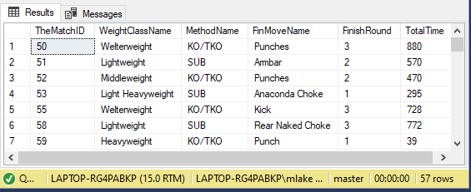

--create view punches by class

CREATE VIEW PunchesByClass AS

SELECT TOP (2000) TheMatch.TheMatchID, WeightClass.WeightClassName, Winner.WinTotStrLand, Winner.WinTotStrAtt, Loser.LoseTotStrLand, Loser.LoseTotStrAtt

FROM Winner INNER JOIN (Loser INNER JOIN (WeightClass INNER JOIN TheMatch ON WeightClass.[WeightClassID] = TheMatch.[WeightClassID]) ON Loser.[LoserID] = TheMatch.[LoserID]) ON Winner.[WinnerID] = TheMatch.[WinnerID]

ORDER BY WeightClass.WeightClassName

GO

--show view of punches by class

SELECT * FROM PunchesByClass

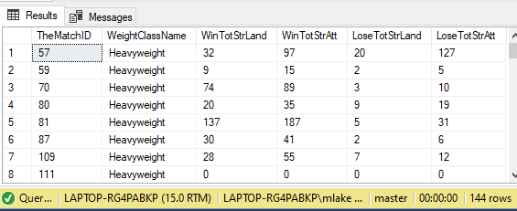

--creating view to see sub att for each match won by sub

CREATE VIEW SubView AS

SELECT Method.MethodName, Winner.WinSubAtt

FROM ((Method INNER JOIN MethMove ON Method.[MethodID] = MethMove.[MethodID]) INNER JOIN Winner ON MethMove.[MethMoveID] = Winner.[MethMoveID]) INNER JOIN TheMatch ON Winner.[WinnerID] = TheMatch.[WinnerID]

WHERE MethodName = 'SUB'

GO

--show view SubView

SELECT* FROM SubView

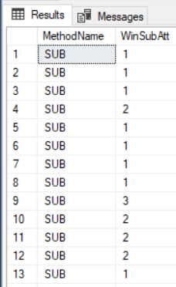

-- Function to retrieve the FighterName for a given FighterID

CREATE FUNCTION dbo.FighterNameLookup(@FighterID int)

RETURNS varchar(20) AS -- vc_userid is an int so well match

BEGIN

DECLARE @returnValue varchar(20) -- matches function return type

-- get username from Fighter record whose ID matches parameter and assigns it to return v

SELECT @returnValue = FighterName FROM Fighter

WHERE FighterID = @FighterID

-- send name back to caller

RETURN @returnValue

END

GO

-- testing Function to retrieve the FighterName with random FighterID

SELECT dbo.FighterNameLookup('9690')

-- Function to retrieve the FinMove for a given MethMoveID from Taleoftape

CREATE FUNCTION dbo.MethMoveDecode(@MethMoveID int)

RETURNS varchar(20) AS -- vc_userid is an int so well match

BEGIN

DECLARE @returnValue varchar(20)-- matches function return type

-- get username from Fighter record whose ID matches parameter and assigns it to return v

SELECT @returnValue = FinMoveName

FROM MethMove

INNER JOIN FinMove ON FinMove.FinMoveID = MethMove.FinMoveID

WHERE MethMoveID = @MethMoveID

-- send name back to caller

RETURN @returnValue

END

GO

-- testing Function to retrieve the finmove with random methmoveid

SELECT dbo.MethMoveDecode('4390')

### Data Manipulation:

/* Update ** realized Mike Pierce Age was entered incorrectly since he fought on his birthday ** */

UPDATE Winner

SET WinAge = '30'

WHERE WinnerID = 146

For this aspect of my project I utilized Microsoft Access to update my Fighter Table with the records of all fighters in my dataset. Also, same with the Winner and Loser tables with the first 40 records. Ultimately, I know this is not the most effective way of updating my tables however, it was most efficient in terms of covering a large amount of data, especially for the thousands of fighters. In addition, I utilized Access to update specific fields such as the President for the UFC in my League table. Any extraneous data that ended up being pasted into my data was deleted using Access as well but, could have been done by deleting the specific row or value from whichever table. I will discuss more of my process in the reflection, however if I had a complete dataset of fight results, I would have at least inserted the round the fight ended in, total rounds, method, move, winner and loser names/ID. This would allow me to utilize various update statements to insert the statistics of each fighter from the match (once I compile it).

## Answering Data Questions:

1. How many fights are finished compared to the number decided by the judges score card?

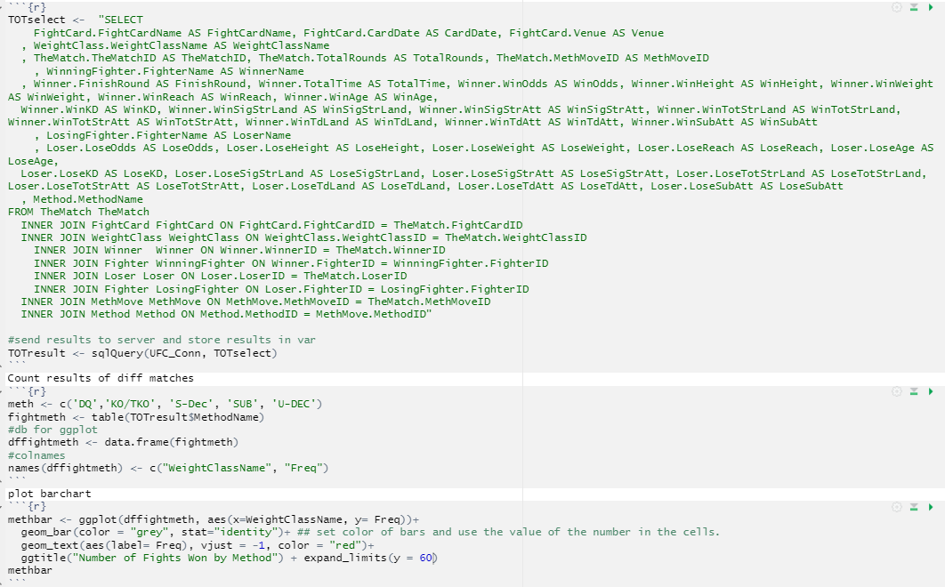

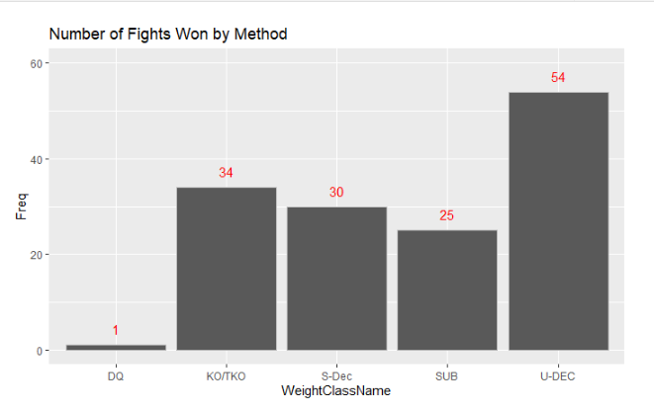

1. What is the most utilized finishing move(s) and how quickly are they executed?

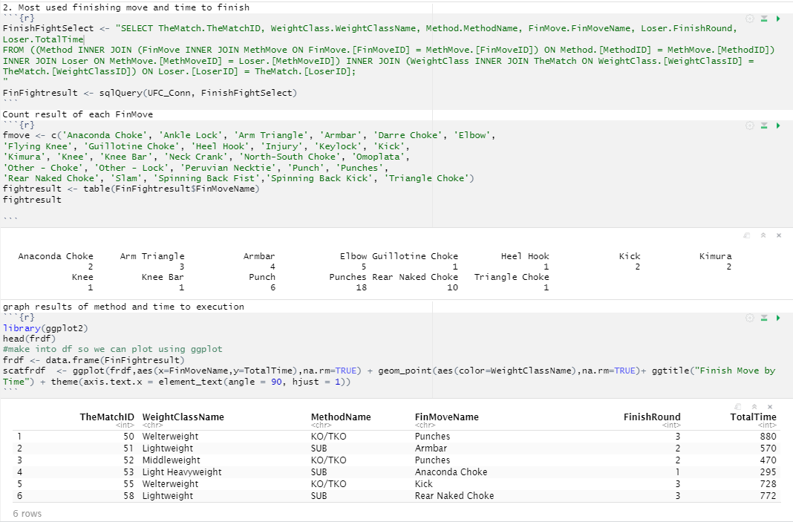

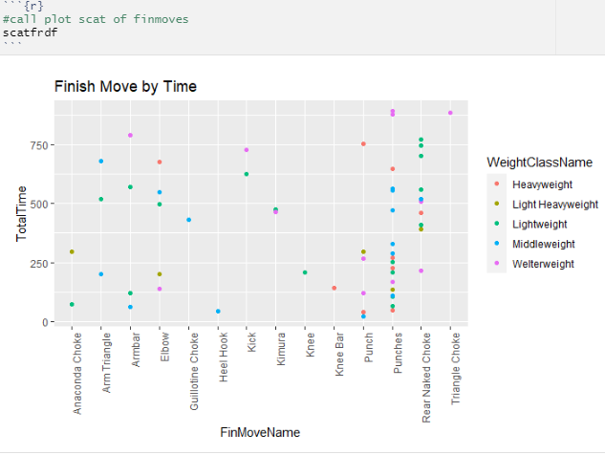

1. What are the differences in strikes landed/thrown for different weight classes?

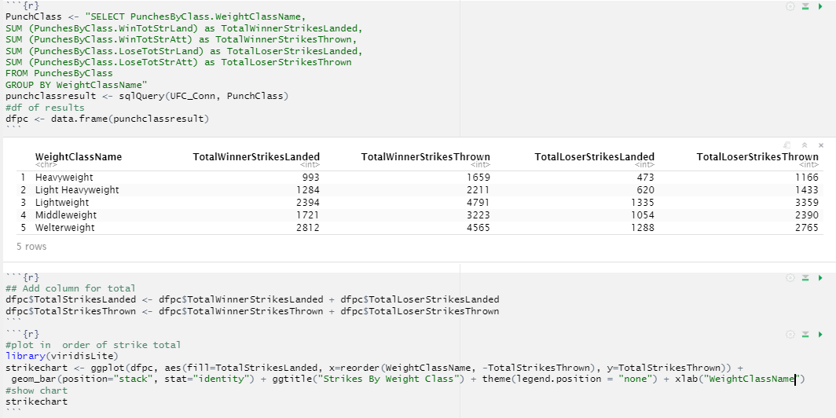 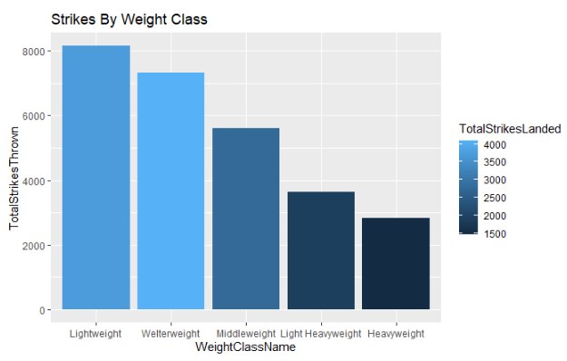

1. What is the average duration of a match and how this differs for weight class?

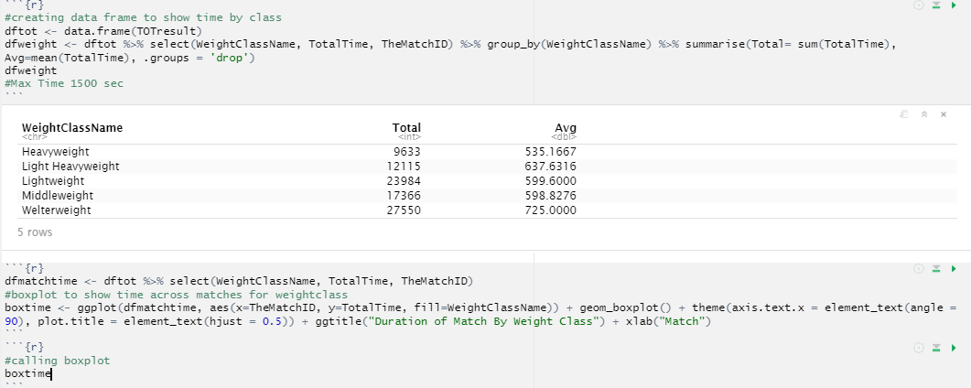

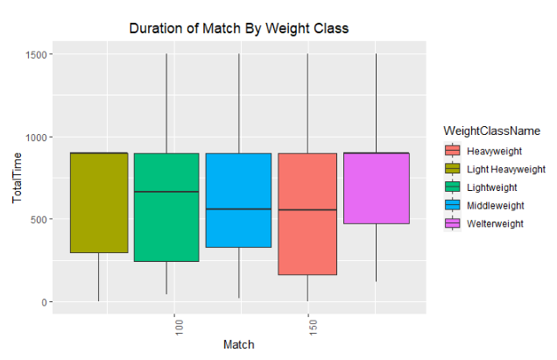

1. How many attempts does it take to land a submission?

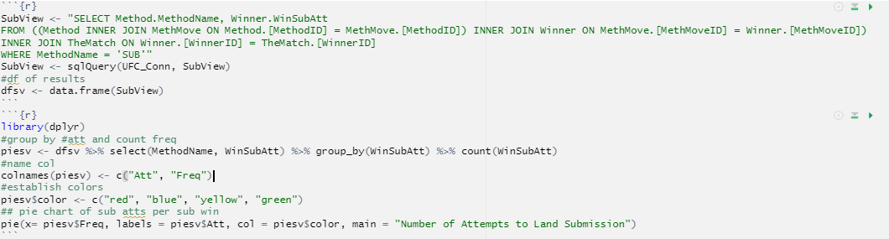

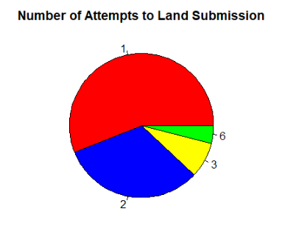

## Implementation:

Using Microsoft Access I generated a form to enter in new match data (TaleOfTape)

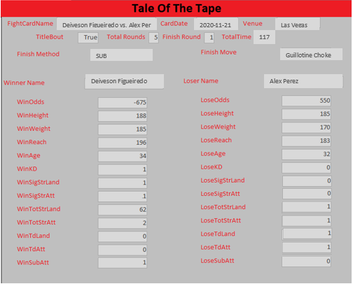

Figure: Screenshots of Access file (to show entry of data and a report of fight card winner / loser)

## Reflection:

I made a few assumptions when planning the scope of this assignment, the most crucial being the way I approached documenting the overall result of a match. Initially, I had created a conceptual model that contained a match table which was intended to contain the names of both fighters and the results. What I had overlooked at the time was the fact that I needed to record the statistics for both the winner and a loser differentiating this in two tables. At the time, I had found a dataset on Kaggle [https://www.kaggle.com/mdabbert/ultimate-ufc-dataset?select=ufc-master.csv] that contained the results of Matches over the past decade.

Ultimately, this was an excellent source of data, however, each line item contained the results of the match, including both fighters’ names, their statistics, and the outcome. The main issue with this data set was that the fighters were organized based on the color corner they were in during the match [red, blue] which became troublesome when moving towards the logical model. This is when I made the decision to break the data down into a winner table and loser table, which captures their specific statistics from the match and allowed for the tables to abide by the normalization rules. After I overcame the obstacle of re-organizing my data, I had the hard realization that if I wanted to utilize this database to create a predictive model, I would need to have a complete and accurate data set. This is when I decided to alter my focus more towards the goals of the assignment and create questions focused on the overall matches rather than a specific fighter across multiple matches. With that said, I selected a subset of my data which included a range of fight cards from 2010 that had a complete set of information. This led to my exploration into comparing the results of a match based on how they ended and the time it took to end. I was able to cater my views to show the difference across the weight classes and how time is factored into the result.

## Summary:

I certainly learned a lot about the process of creating a relational database in SQL language as well as the integration of front end and statistical computing software. Before beginning the term, I was familiar with these concepts and had minimal exposure to Microsoft SQL Server, R [R Studio], and Access. Thankfully, I had been enrolled in a course that utilized R while taking on this assignment.

I now have a new outlook on Data Science as well as the integration of different tools with my added knowledge on how to work seamlessly across multiple software platforms. Overall, I am amazed at what I was able to accomplish in completing this assignment. I had developed my own process of pulling data from an excel workbook to concatenate the needed characters around the cells of data to develop my insert statements. This is one of the many ways I relied on my intuition to overcome the challenges of building a database in SQL and transferring over my data. I will rely more on this method in future iterations rather than pasting my data into the front end of the table via Access.

Lastly, I plan on executing my original goal of this project in creating a predictive model, hopefully soon. I now have a fully working relational database to store all the match results spanning 10 years once I go back in and clean up the data. I also have the tools to run a statistical analysis on this data with the integration of R and can continue to update my database with the use of the form in Access. I am excited to continue to develop this project and would not have been able to achieve its current state without the knowledge acquired throughout this course.